TASK ON JENKINS 3

Create one Jenkins job using the below code and create three stages.

stage1: Git clone to download the source code.

Created 1 job in that got to source code and paste the GitHub link and save.

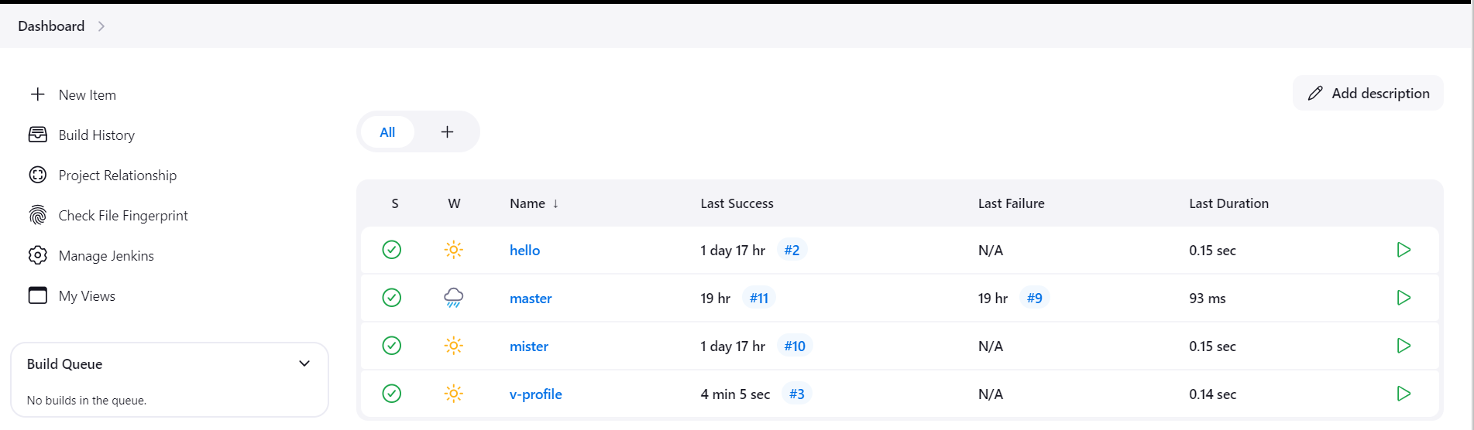

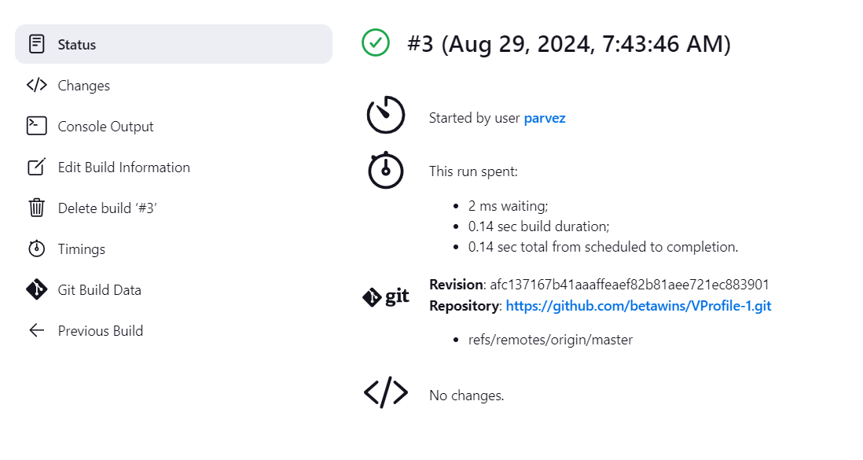

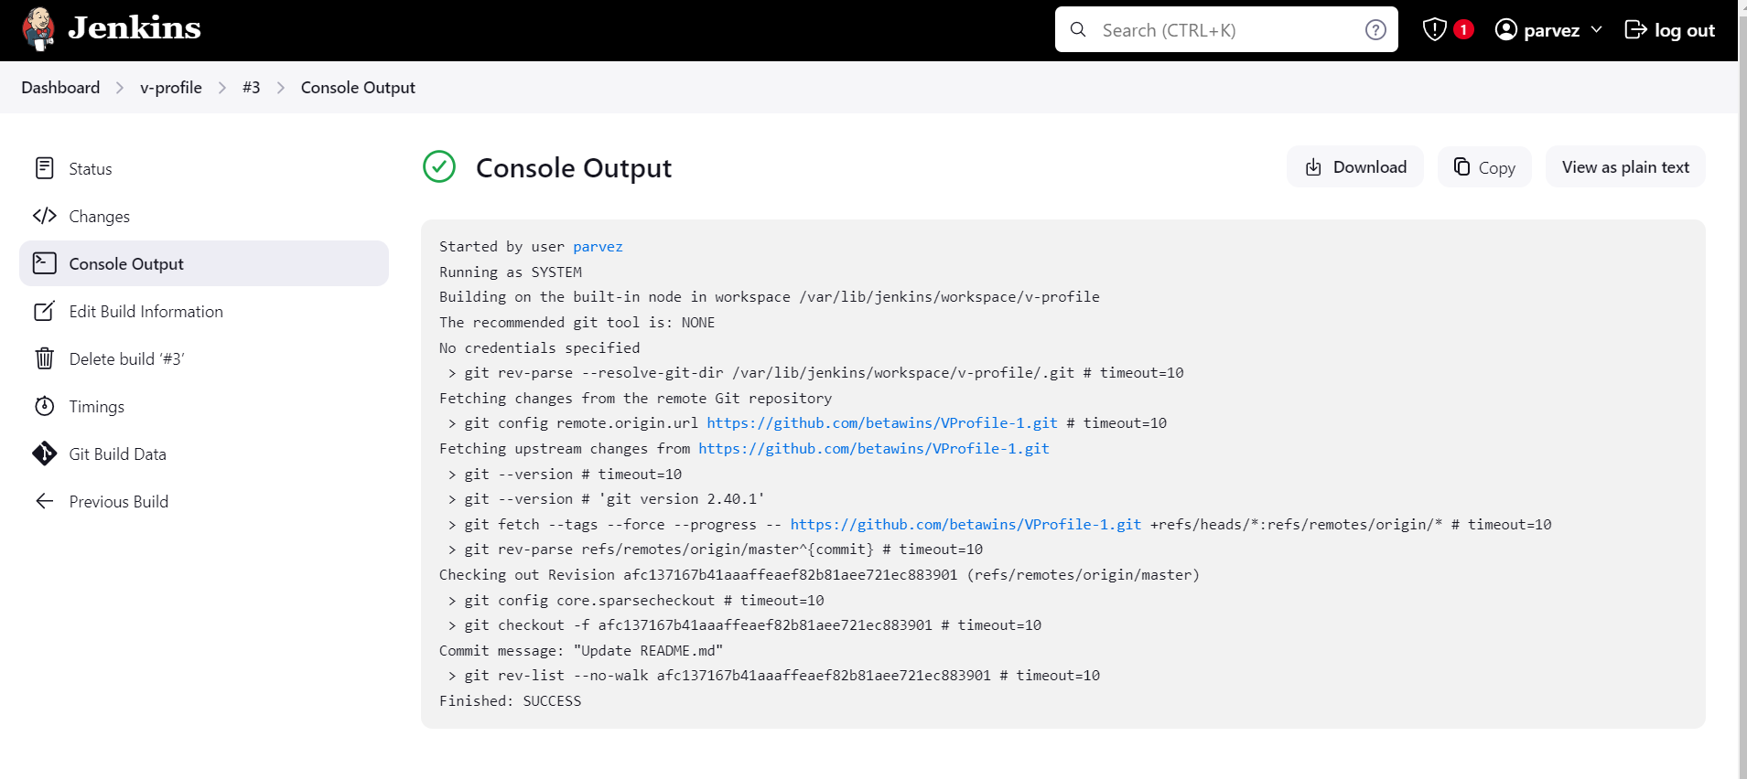

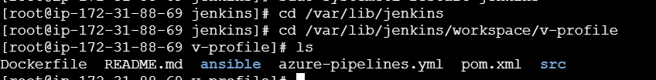

stage2: Sonarqube Integration to check the quality of code

----- need to install sonarqube with the help of documentation given

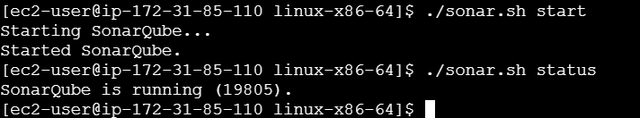

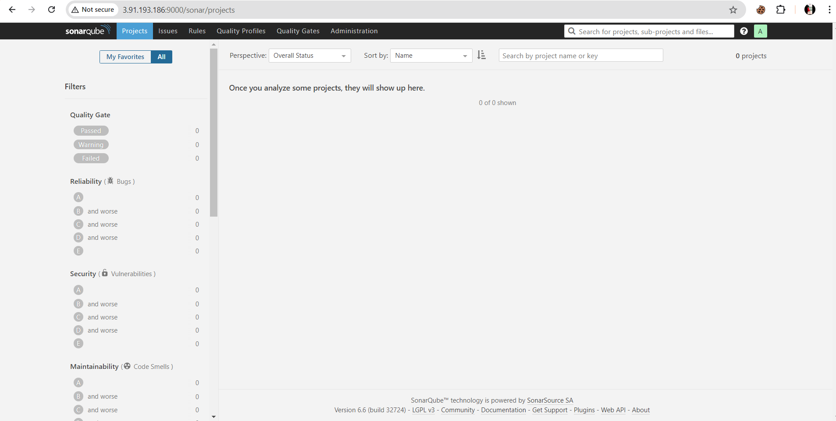

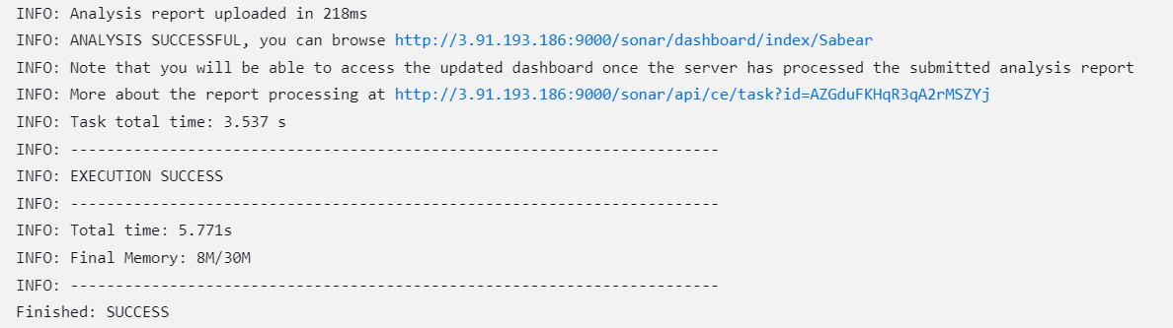

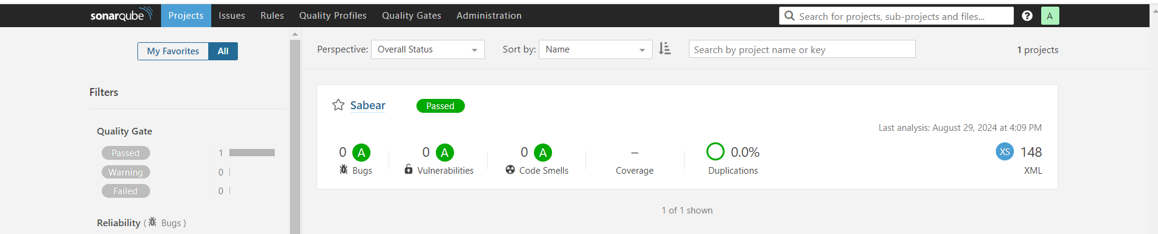

stage3: Slack Integration to send the alerts to slack.

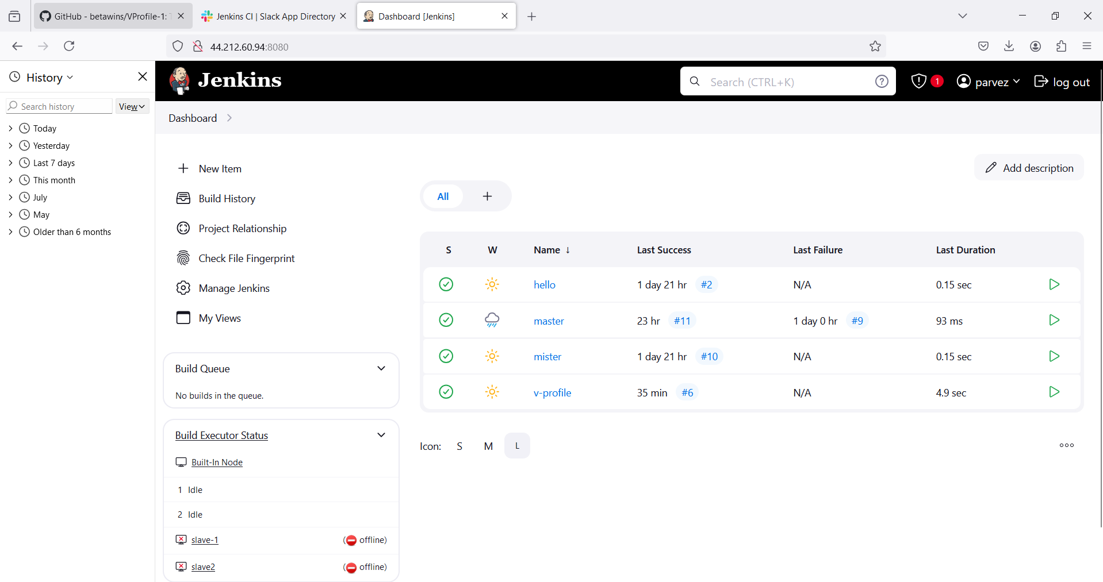

Got a message in slack in jennu channel

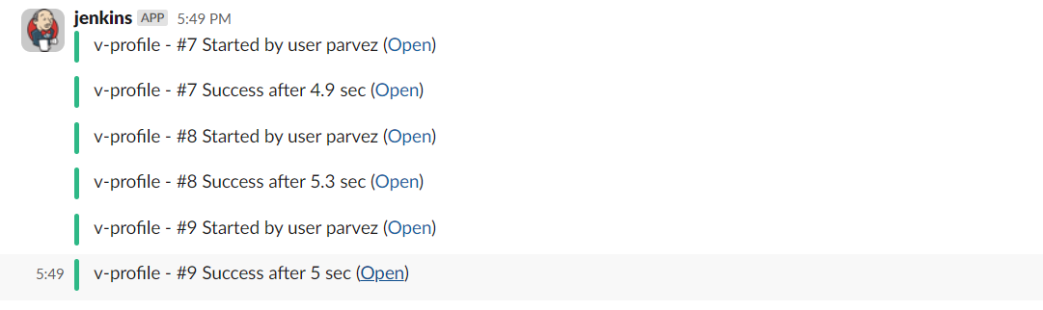

1. Create one jenkins job using the below code and create three stages.

stage1: Git clone to download the source code.

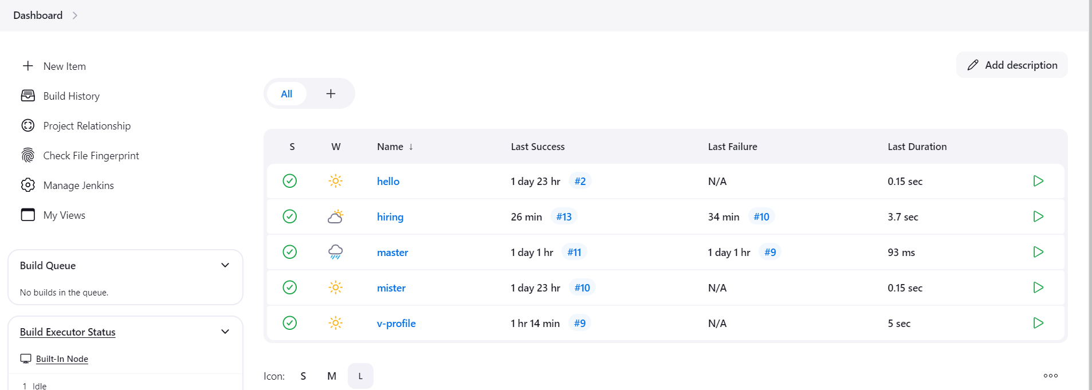

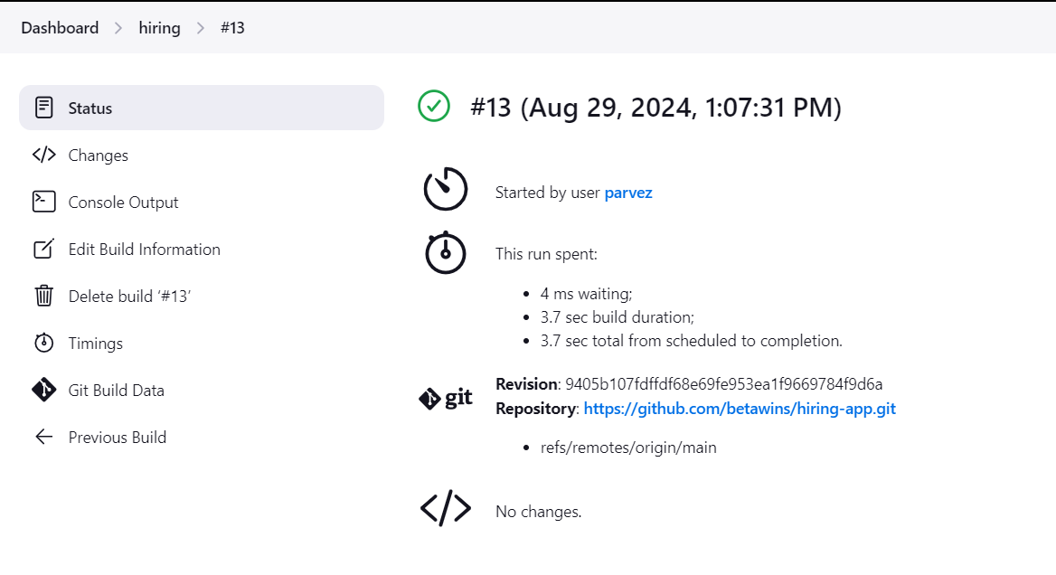

1. stage2: SonarQube Integration to check the quality of code

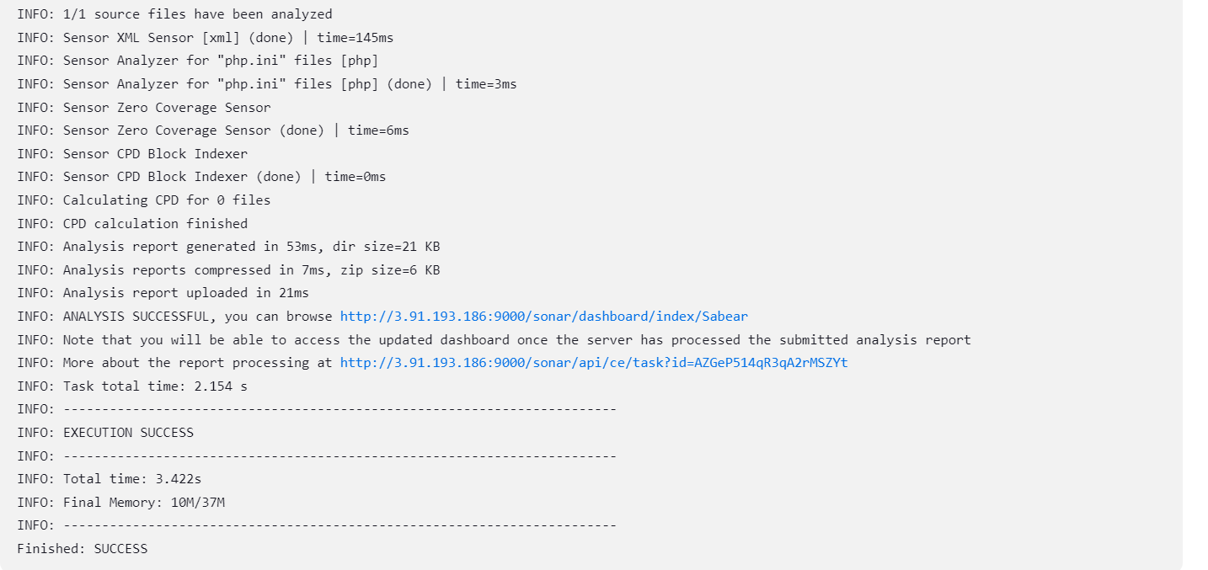

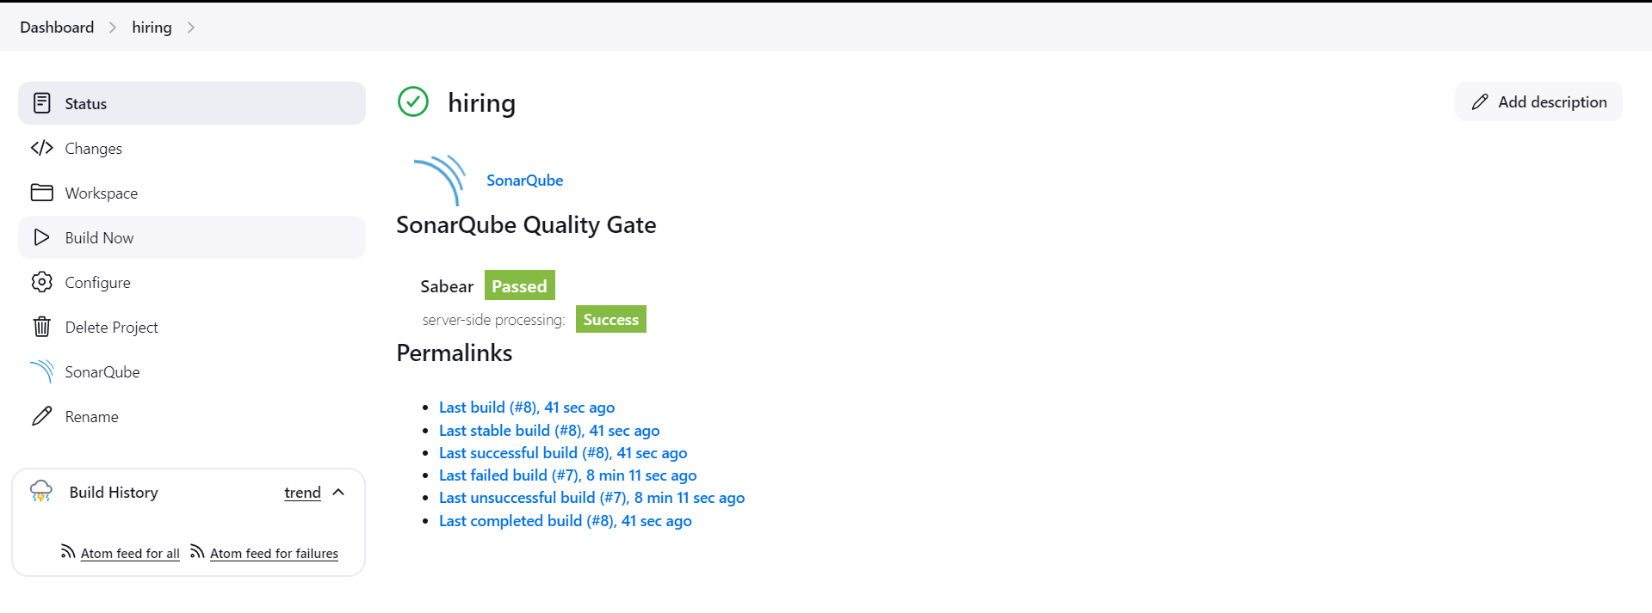

stage3: Slack Integration to send the alerts to slack.

